**FSG WORK SOLUTIONS INTERNATIONAL LIMITED**

***(Career, ICT & Financial Strategy Consultants)***

**CORPORATE PROFILE**

FSG Work Solutions International Limited is a Nigerian registered company that specializes in recruitment, training & development and financial strategy consulting. We are a team of professionals committed to helping people get jobs and teaching them how to achieve financial freedom using 21st century technology.

**Our Vision Statement**

*To be the market leader in the use of technology to connect individuals and organisations to modern opportunities for financial advancement.*

**Our Mission Statement**

*To expose at least 10,000 persons every year to new opportunities and guide them towards achieving financial freedom.*

We solve the following problems:

1. Unemployment/underemployment
2. Financial struggle in employment
3. Financial crisis at retirement

We help our candidates become productively engaged in a matter of days with the aid of modern technology.

We help employers to easily get staff by supplying them with qualified candidates free of charge.

We have a vast network of employers in our data base that we supply staff on request at very short notice.

**OUR BUSINESS PLATFORMS**

To carry out our activities, we have the following business platforms:

1. **Recruitment, Training & Outsourcing Platform**

This is for fresh graduates looking for first time jobs or for experienced hands looking for better jobs. We take you through our orientation programme after which we professionally re-package your CV and market it aggressively within our vast and growing network of hiring companies across the country.

1. **E-Commerce & Digital Business Platform**

We have a full-fledged e-commerce website as well as online shops on WhatsApp. We sell mainly food and allied products.

We also have a platform for the sale of various digital products – e-books, courses, business solutions and job packages.

We have digital job packages for Students, Job Seekers, Workers and Retirees.

1. **Real Estate and Agriculture**

We run a 170 acre farm in Laminga, near Keffi in Nasarawa State.

The farm is run as a farm estate (just like a residential estate) where interested investors can buy land and own their farms just like a residential estate.

We also do warehousing of selected agro produce both on our behalf and on behalf of our investors. We buy the produce during harvest for storage and sell during planting season when the price is much higher.

1. **Accounting Services**

We render sundry accounting services to organisations such as book keeping, financial statement analysis, fraud investigations, setting up of accounting systems, etc.

We also render remote and digital accounting services.

1. **Business Consulting**

We help companies migrate their business online.

We help companies double their sales in 2 years with the aid of digital technology.

We help companies manage their social media platforms.

We help companies minimize their costs and maximize their revenues.

**OUR KEY RESOURCE PERSONS**

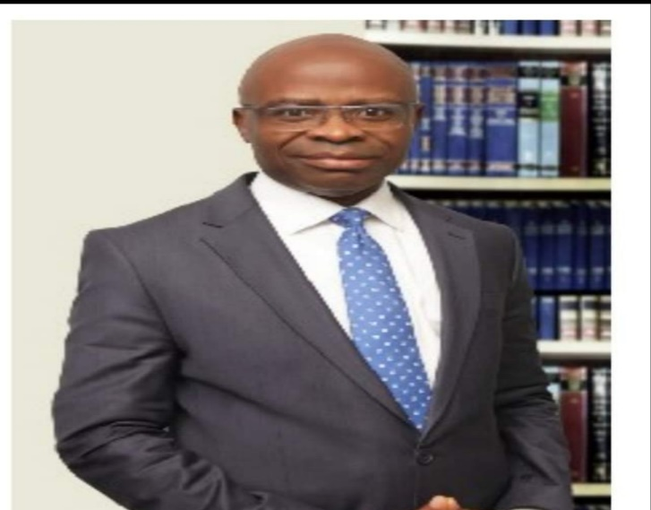

**ONYILOKWU, ANDREW OCHOFIE**

**(B.Sc, MBA, FCA, HCIB, ACIT, ACS) – Chairman**

Andrew is a Chartered Accountant, Chartered Banker and Chartered Stockbroker with about 30 years’ experience in financial services and consulting. In the course of his career, he has served as Chief Financial Officer and Chief Internal Auditor in Nigerian banks quoted on the Stock Exchange. He also served as Executive Director, Finance & Benefits Administration in one of the leading pension fund administrators in Nigeria.

He is a graduate of Accounting from the University of Jos and has attended varied executive training courses in various prestigious institutions including Lagos Business School, Harvard Business School, University of Chicago, Stanford University, Columbia University, Wharton Business School and Kellogg School of Management.



**GBEMISOLA ANDREW – Managing Director**

Gbemisola is an Accountant and a seasoned entrepreneur. She has over the years garnered real life experience in running SMEs such as supermarket, company distributorship, car wash, consumer products importation, produce warehousing and marketing, farm operations and real estate business. She is also a Consultant and Trainer and is currently the Managing Director of FSG Work Solutions International Limited.



**BENEDICTA ARACHIE – Senior HR Specialist**

Senior HR Offficer and Professional CV Writer with over 4 years experience working with graduates, job seekers and professionals within and outside Nigeria. She has professionally re-packaged over 4,000 cvs out of which about 85% have been productively engaged with their dream jobs.

**OUR CONTACT ADDRESS**

You can contact us via our website –

or our office location:

*Abuja – Suite 325 Rock of Ages Mall, Utako (beside A A Rano Fuel Station) Abuja*

Phone Nos: 0814 6695 940 or 0708 2222 771)

**OUR UNIQUE APPROACH**

Our unique approach to business stands us out in the marketplace.

* We are the only Human Resources company that send out candidates to employers free of charge.
* We are the only Human Resources company that form and maintain long term relationships with our candidates for career progression and ultimately financial freedom.
* We are the only Human Resource company that has business platforms to ensure that our candidates can practically engage in digital jobs while waiting for their regular office jobs.